1. Please login to the Epam Auto Code Platform and Click on the Subscribe button.

URL: *https://autocode.lab.epam.com/student/group/221*

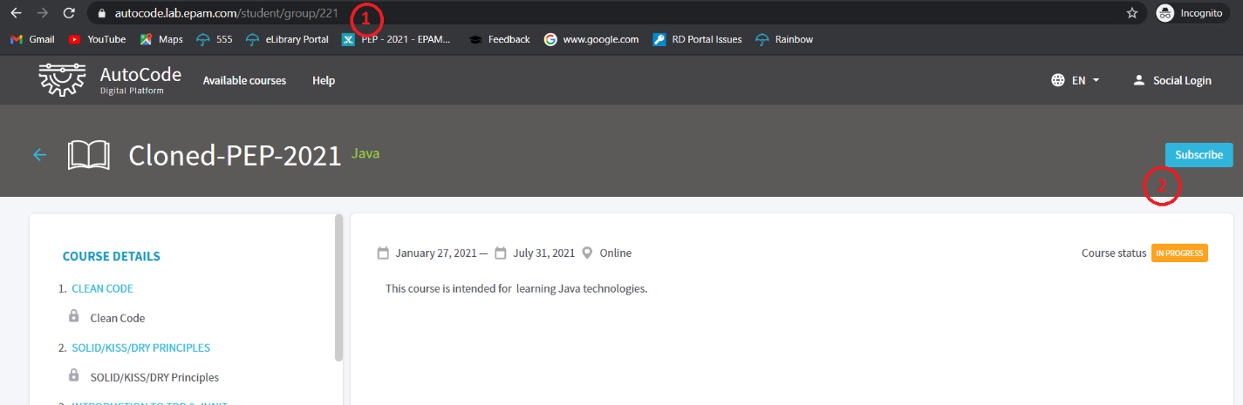

1. Please login to the application with your register email id of Epam PEP Program to subscribe.

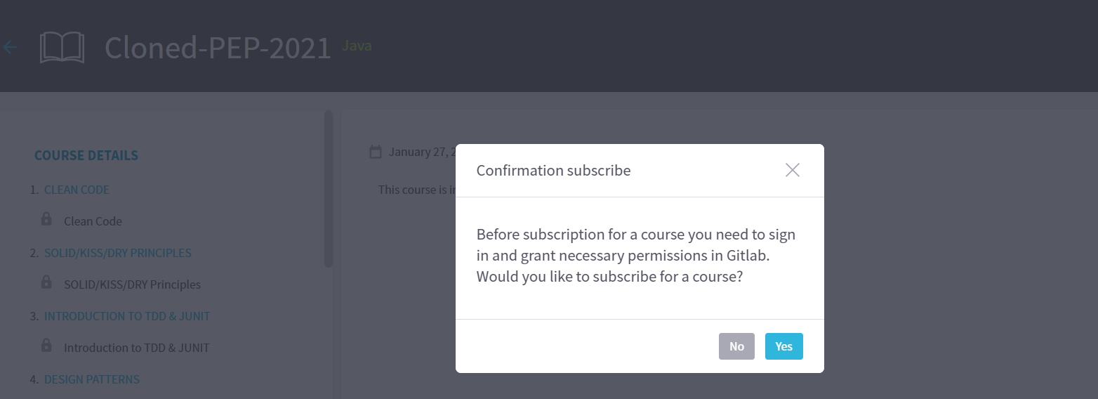

1. Please use Git Lab account to login.

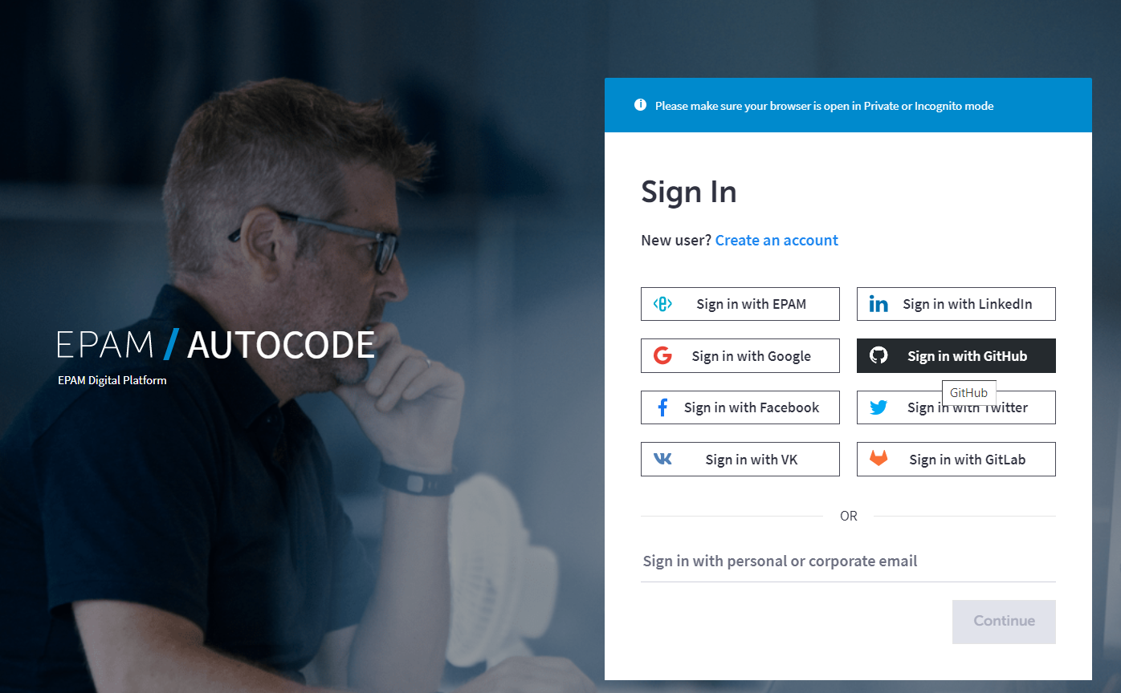

1. After successful login, you will be navigated to the below dashboard where all the topics are listed.

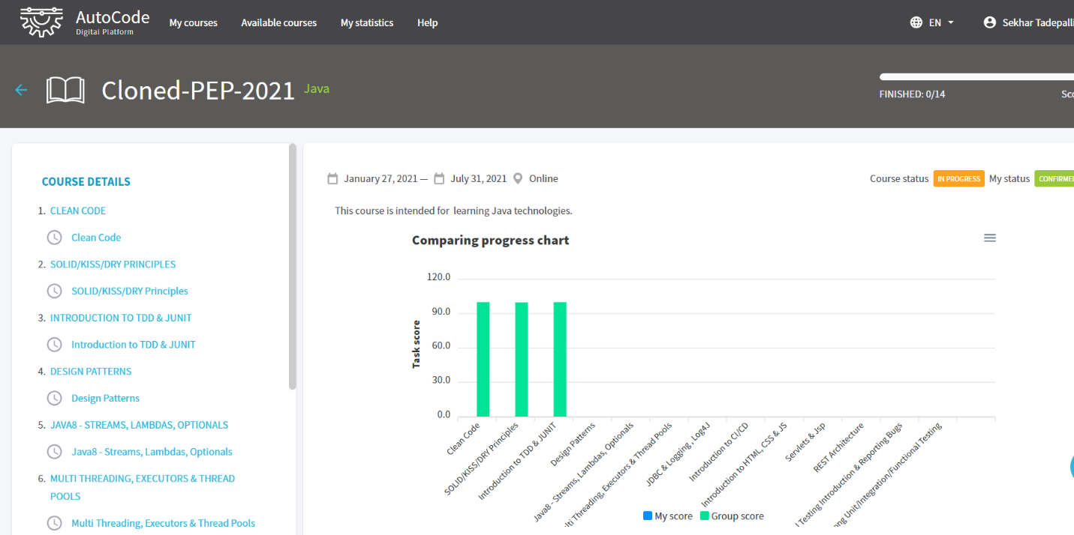

1. Now you can click on the “SOLID/KISS/DRY” principle topic and click on Start Button.

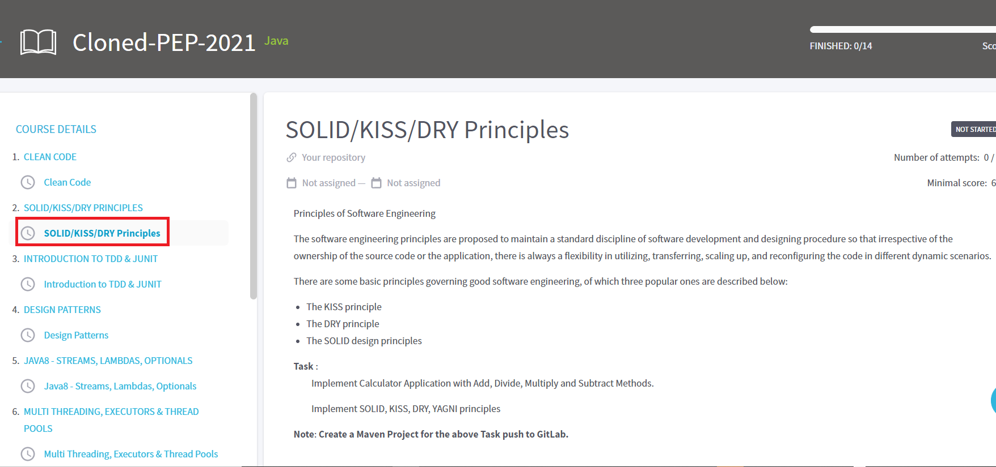

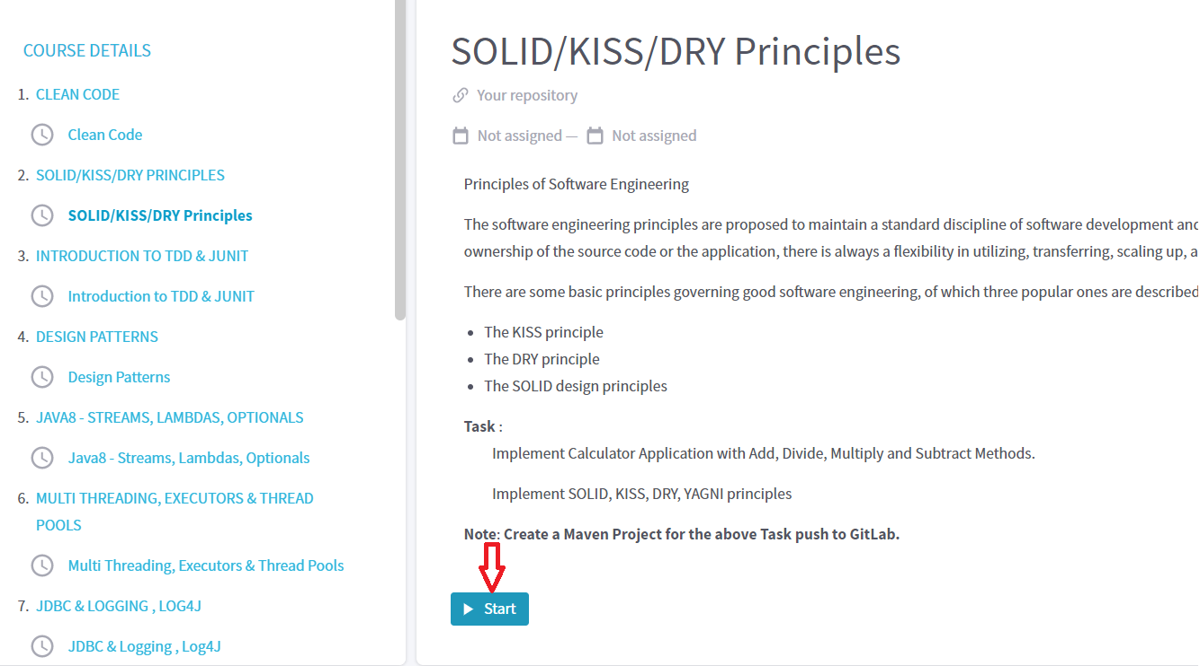

After clicking on the Start button, One of the Git Lab account will be forked from the configuration and execution process will be initiated with SonarQube.

After SonarQube analysis, result will be displayed with the comments. Please review the code and re-upload if it is required.